***Project Phase V***

***On­­­***

**3-D Multiplayer Game(Tic-Tac-Toe)**

**Submitted for the requirement of**

**Project course**

BACHELOR OF ENGINEERING

**COMPUTER SCIENCE & ENGINEERING**



**Submitted to: Priyanka Sharma(E6197) Submitted By: Sahul Kr. Parida(20BCS4919)**

**(Project Supervisor) Saksham Thakur(20BCS4970)**

**Sudhanshu Kumar(20BCS4953)**

**Co-Supervisor Signature**

**Archana Kumari (E13569)**

**DEPARTMENT OF COMPUTER SCIENCE & ENGINEERING**

**CHANDIGARH UNIVERSITY, GHARUAN**

**November 2022**

**Table of Contents**

Outcome and Work Ethics

1: IMPLEMENTATION AND RESULT 3-5

2: CONCLUSION AND DISCUSSION 5-6

3: OUTPUT 7-13

**IMPLEMENTATION AND RESULT**

# **1.1 Introduction**

System implementation is the process of defining how the game should be build, ensuring that the game is working in term of operational and meets its quality standard. During the implementation phase, a few tests for the game had been done. Testing is a process where executing takes place with intent to finding the errors. This chapter will explain about the implementation and testing of 3D simulation game.

## 1.1.1 Deployment and Configuration

In developing phase of this project, it used C Sharp programming language. To write the script, Visual Studio is the platform for developer to manage the code as the project will be.

The Microsoft Visual Studio has been used to write the code. For interface design, it used different software which is the main software, Unity 3D 2018.

## 1.1.2 Interfaces Design

User interface design is the design of computers, appliances and software application with the focus on the user’s experience and interaction. The goal in designing user interface is to make a great interaction between user and the application in term of efficiency, user-friendly, compatible of the system with target users. The interface should be understandable, easier to use with a proper arrangement of game flow.

# **1.2 Testing and Result**

Testing is one of an important phase in the development of the project. This phase works to test the system or application whether it fully function or vice versa. In this phase, there are three types of testing to test the system which is unit testing, integrate testing and system testing. Unit testing is carried out to verify the functionality of specific section code. Integration testing is to an exposed defect in the system interfaces and interaction between modules.

## 1.2.1 Games Functionality Test for Player

|  |  |  |  |
| --- | --- | --- | --- |
| **Step** | **Procedure** | **Expected Result** | **Result** |
| 1 | Start Menu | Display Main Menu | Success |
| 2 | Click on Option Button | Display Option Window | Success |
| 3 | Adjust Volume Slider | Volume increase or decrease | Success |
| 4 | Click on Back Button | Display Previous | Success |
| 5 | Click on Start | Starting the Game | Success |
| 6 | Click on Quit | Close the Game | Success |
| 7 | Mouse movement | Camera view of player | Success |
| 9 | Keypad (WASD) avatar movement | Avatar move in x-axis and y-axis | Success |

Table 4.1: Table Functionality Test

# **1.3 Chapter Summary**

The implementation of coding and testing of the system is discussed in this chapter. For creating high quality graphic and well AI system, all test cases must be tested carefully to ensure the intended result. Next, the main menu and flow of the game are discussed. Finally, the discussion related tested and evaluated of the game functionally.

**2.** **CONCLUSION AND DISCUSSION**

# **2.1 Introduction**

In this chapter, the goal and objectives of the project is discussed and concluded. Other than that, this chapter also included the project constraints and possible future work that should be took in the future.

# **2.2 Project Contribution**

This game is developed for simulate the student life besides getting experience around Virtual environment in 3D form. It also tells a lot of information about three dimensional world and virtual experience. This application had achieved the objectives and all scopes had been fulfilled. The achievement of this project is:

* Player can move their avatar freely inside the game with virtual environment in 3D form.
* Player experience the simulation game on 3-D.
* Player know the layout of the 3-D Virtual World.

# **2.3 Result Discussion**

Generally, the project has been carried out and followed the objectives that had been stated in Chapter 1 previously. In this project, player will either successfully play this game. The result of this project is 3D simulation game are developing, design based on real campus and clean from any violent that can influence and affecting the player.

# **2.4 Limitation**

There are several problems and limitations while developing this project. These are the problems and limitations in conducting this study are:

* The high quality of graphic cannot be creating because of computer lagging.
* The map of the environment is limited due to low PC performance.
* The high quality of artificial intelligence (AI) cannot be implement.
* The game is for PC only.

**2.5 Recommendation**

Although the application works properly and follows the milestones of project respectively, there exists some changes can be taken for better performances. The constraint as described before this can be corrected and improve the quality for the future. The developer must come up to date with the current technology to ensure the application that developed will meet the standard. The function of loading and saving the current progress that have been played must be created so that player can continue their journey inside the game.

# **2.6 Conclusion**

By the end of this study, this project is expected that game can be a new way to promote Virtual World to people. As we all know, each university have their own portal website to put their information for people getting information. This project may not replace the function of the portal website but can be another interesting way to promote and put information. After playing this game, people can relate the real layout with the 3D layout of the campus. Furthermore, the game is very friendly-user with guide that can be understand easily.

**3. OUTPUT**

**3-D Tic Tac Toe**

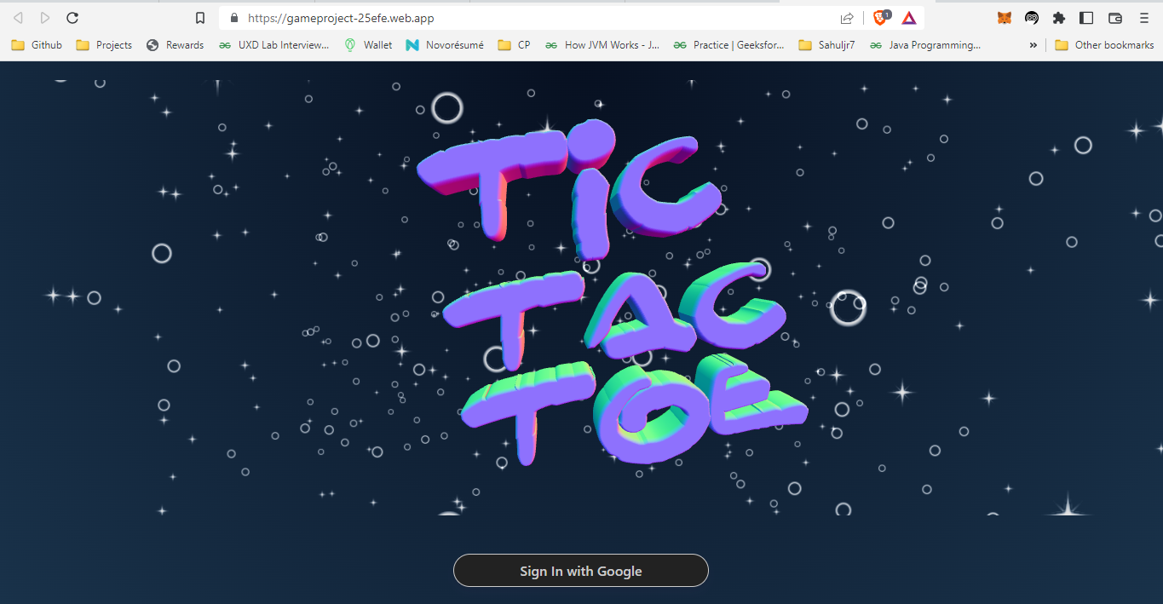

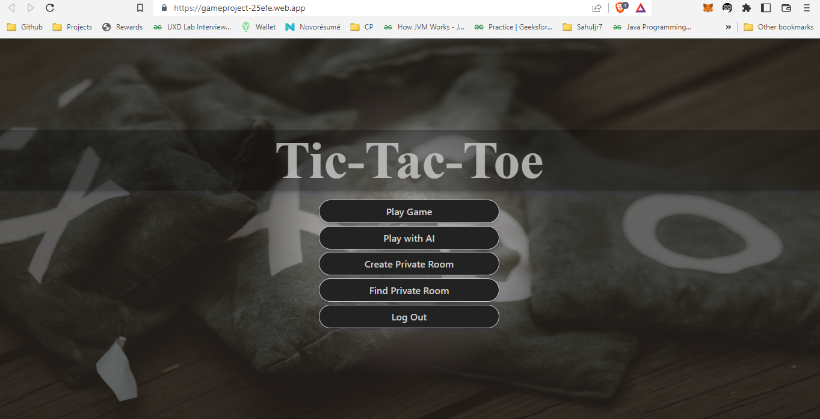

Play Game(Random Matchups)

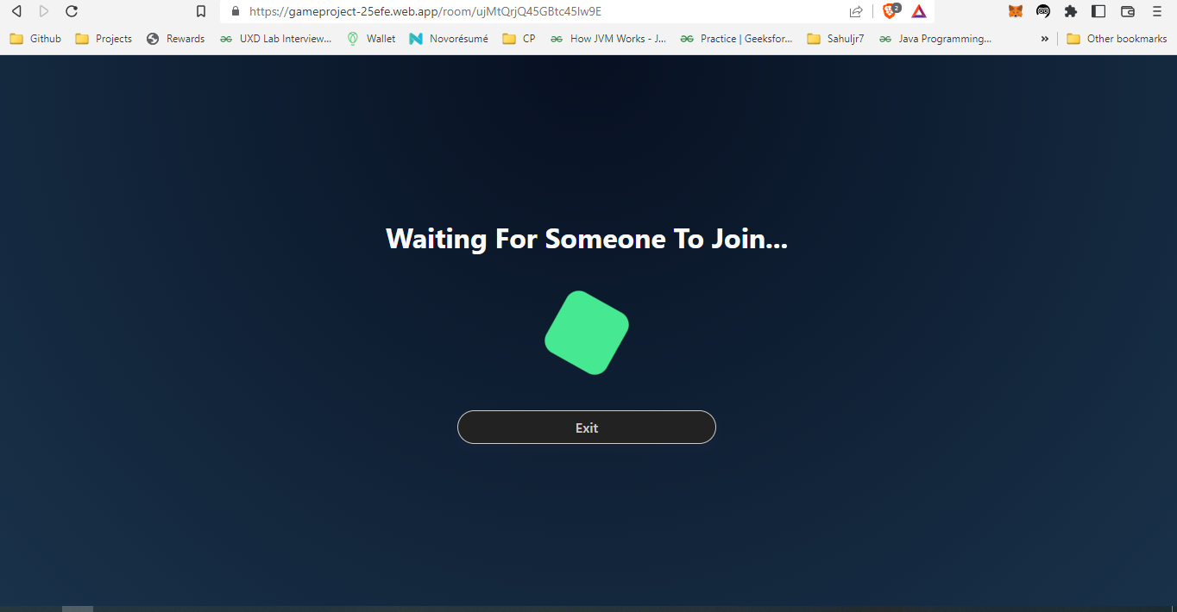

Play with AI

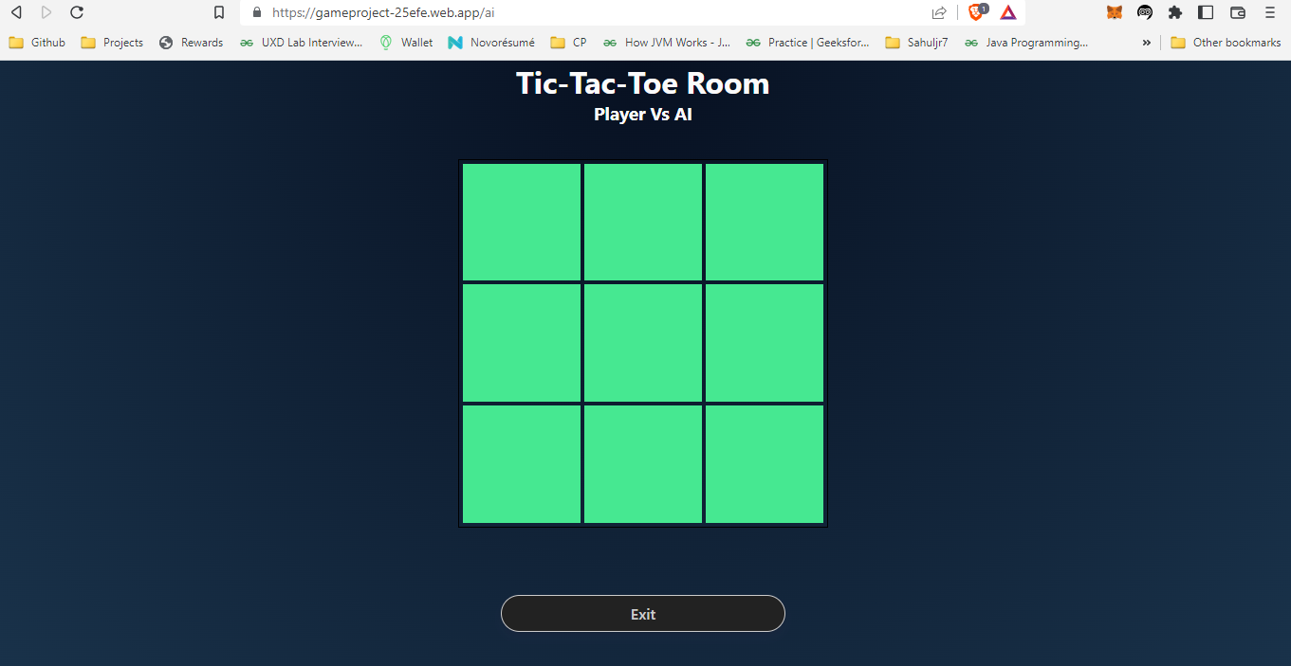

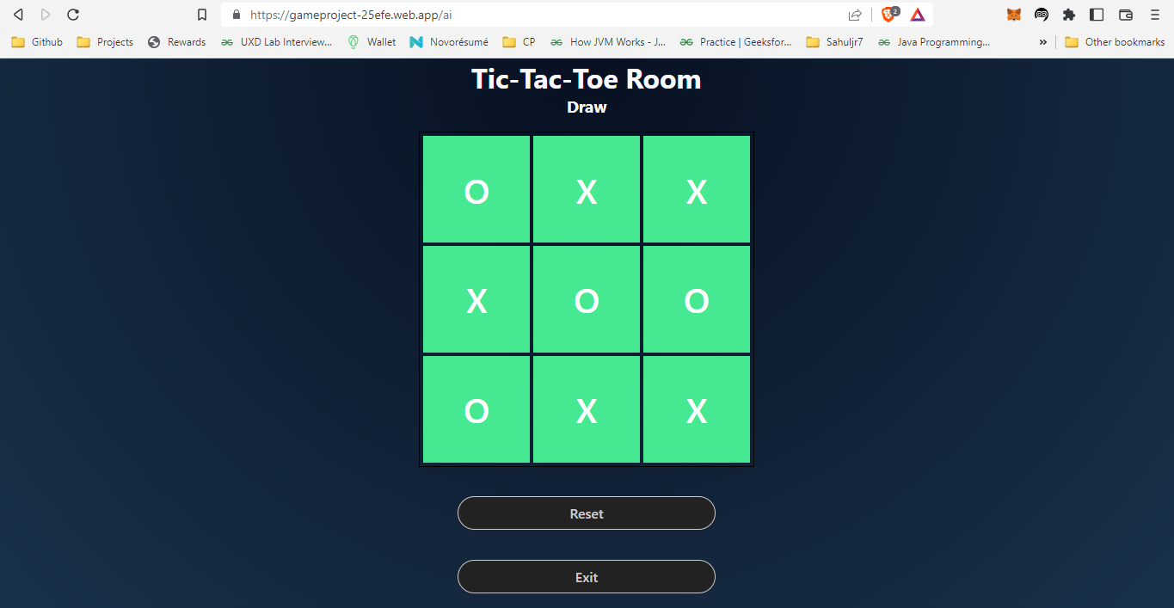

Create Private Room

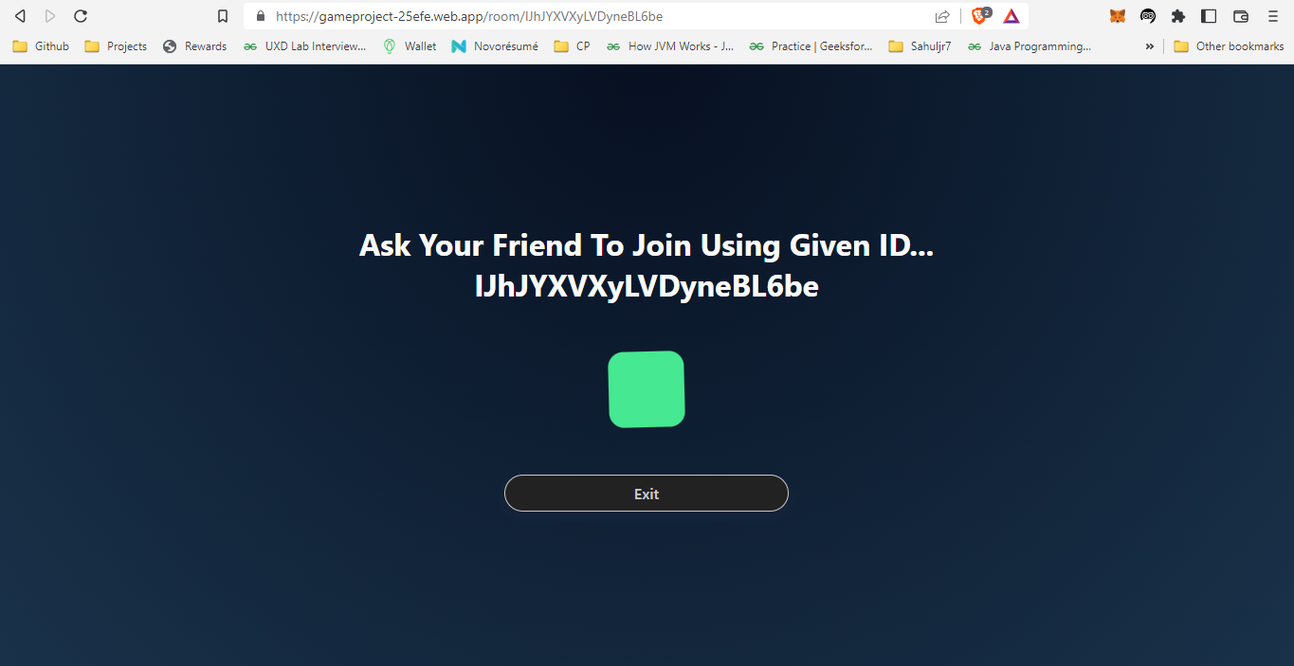

Find Private Room

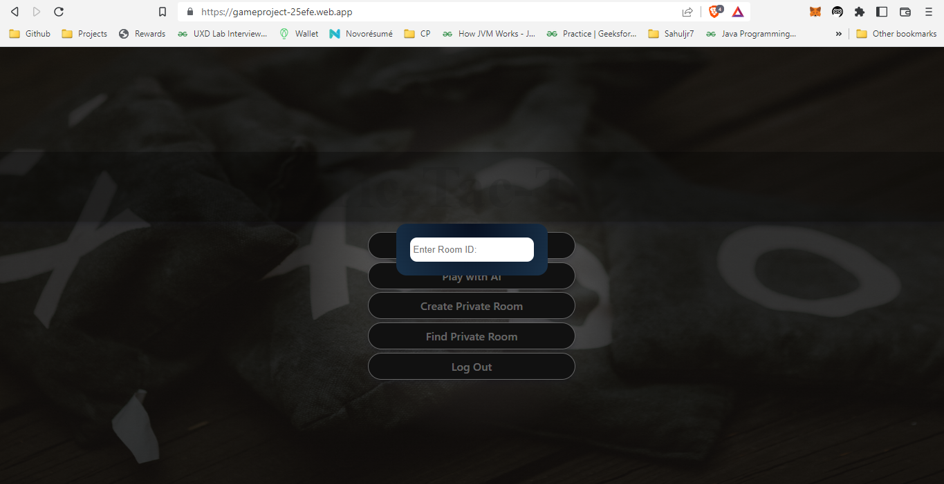

**3-D Virtual Store**

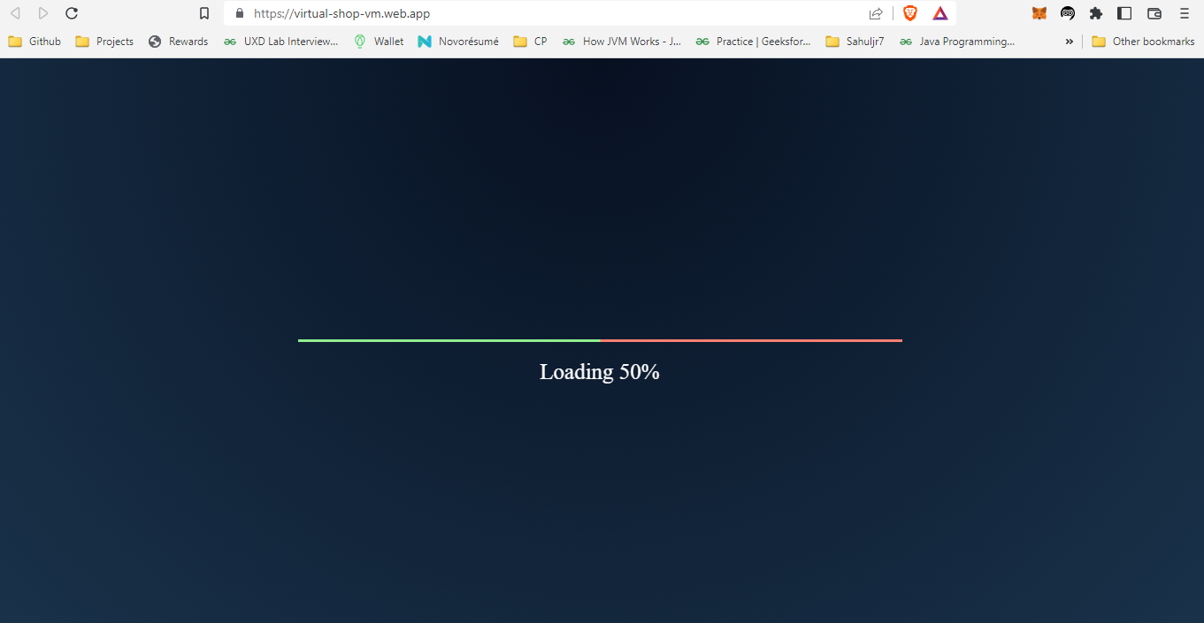

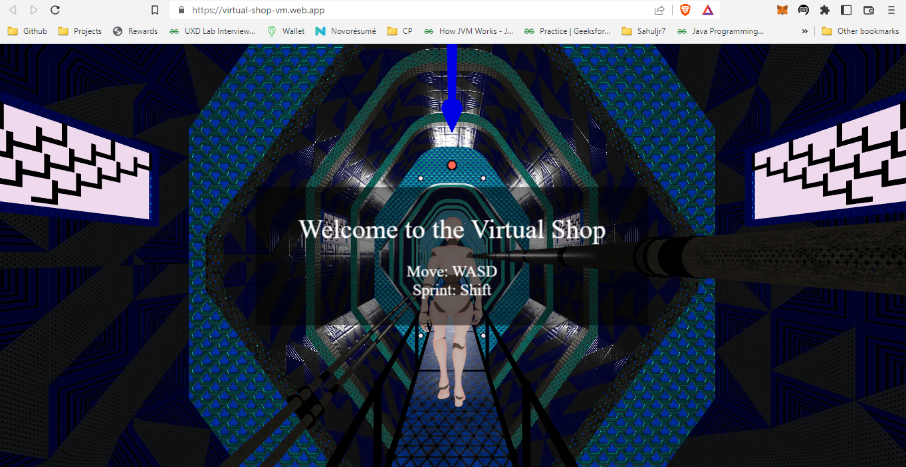

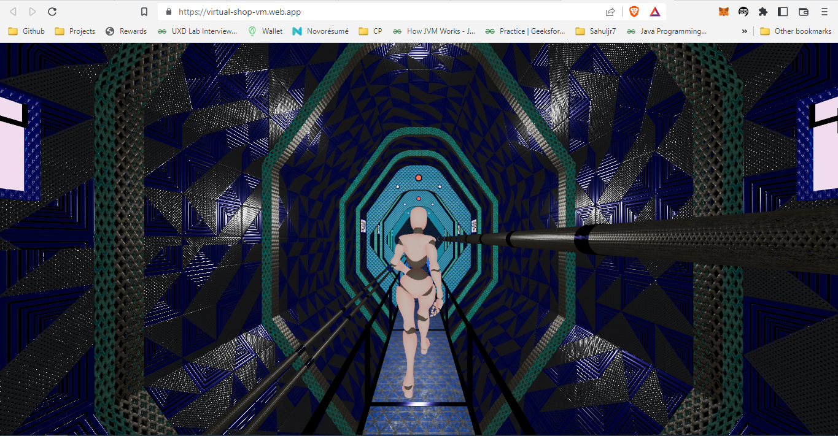

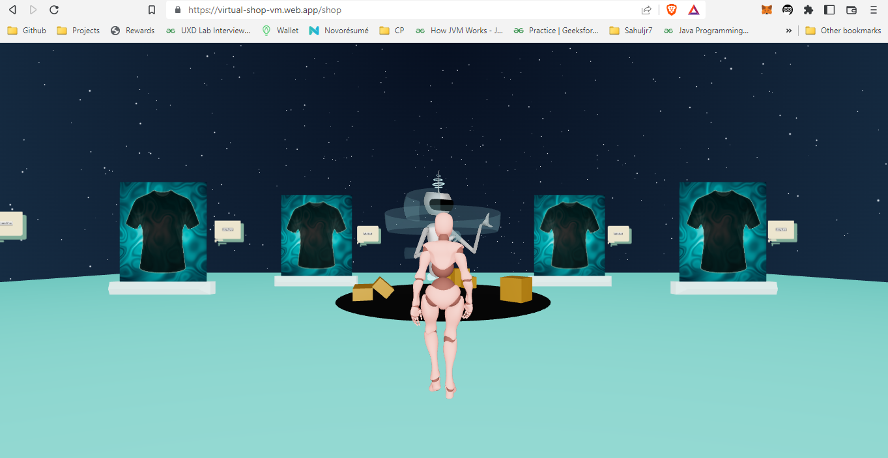

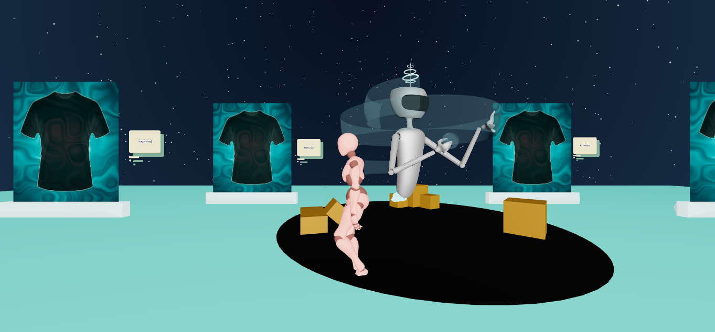



# **REFERENCES**

1. Mukherjee, Souvik. “Introduction: Video Games and Storytelling.” Video Games and Storytelling, 2015, pp. 1–21., doi:10.1057/9781137525055_1.
2. “Embodying Character in Storytelling.” Performing Story on the Contemporary Stage, 4 Feb. 2013, pp. 9–10., doi:10.1057/9781137356413.0005.
3. Huber, Amy M. “Visual Storytelling.” Telling the Design Story, pp. 101–129., doi:10.4324/9781315226132-6.
4. Pitcher, Jenna (9 October 2013). "Grand Theft Auto 5 smashes 7 Guinness World Records". Polygon. Vox Media. Archived from the original on 9 October 2013. Retrieved 9 October 2013.
5. Jackson, Leah B. (June 9, 2014). "E3 2014: The Sims 4 Release Date Announced". IGN. j2 Global. Retrieved June 9, 2014.
6. Wagner, Jayce (June 13, 2017). "In The New 'God of War 4' Trailer, Kratos Is Old, Grizzled, And as Brutal As Ever". Digital Trends. Designtechnica Corp. Archived from the original on April 13, 2018. Retrieved June 22, 2017.